**Logarithm – Definition, Rules , Furmulas and Examples**

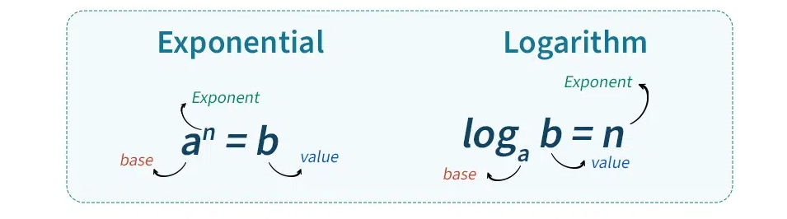

**Properties of Log**

